# How to deal with the web.config size limit in order to add URL redirects?

We will use the *URL Rewriter for .NET* library: <https://web.archive.org/web/20150804150806/http://urlrewriter.net/index.php/support/reference/actions/rewrite>

1. In the web.config file add the following changes to include the rewriter module:

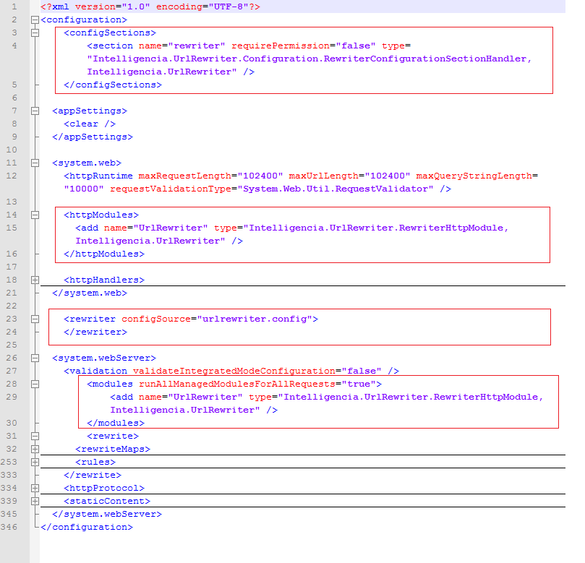

1. Create bin folder and put the Intelligencia.UrlRewriter.dll



1. Use an external file (**urlrewriter.config**) to put all redirects indicating which URL to which one to be navigated:

